MINI PROJECT REPORT
ON
MOVIE RECOMMENDATIONS SYSTEM

Submitted to Uttaranchal School of Computing Sciences in the Partial Fulfillment of the requirements for the Degree of Bachelor of Computer Applications ( BCA-AI&ML ).

UTTARANCHAL UNIVERSITY
Session 2025-26

SUBMITTED TO: SUBMITTED BY:
MR. DEEPAK KUMAR PANT SUJAL THAPA
Assistant Professor UU2509000333
USCS BCA 2B

ACKNOWLEDGEMENT

The most awaited moment of any endeavour is successful completion, but nothing can be done successfully if done alone. Success is the outcome of contribution and consistent help of various persons and we thank the ones who helped us in successful completion of this project. First and foremost, we would like to thanks Prof. (Dr.) Sonal Sharma, Director, USCS for providing a healthy and encouraging environment to study.
We profusely thankful to the Prof. (Dr.) Sameer Dev Sharma, Head of Department, USCS and our project Mentor Mr. Deepak Kumar Pant been generous enough to provide us an opportunity and accepting our candidature for the most valuable guidance and affordable treatment given to us at every stage to boost our morale.

We express our sincere gratitude to our colleagues with whom we have fruitful discussions which have helped us a lot in giving a final shape to the program.

SUJAL THAPA
BCA (AI&ML) 2ND SEMESTER
ENROLL NO. - UU2509000333

DECLARATION

I, Sujal Thapa S/o Mr. Jeevan Bahadur bearing student of Bachelor of Computer Applications , hereby declare that the project report entitled MOVIE RECOMMENDATIONS SYSTEM submitted to the USCS, Uttaranchal University, Dehradun , is a record of an original work carried by me under the guidance of Mr. Deepak Kumar Pant and this project work has not been submitted to any other University / College for the sake of award of any degree.

SUJAL THAPA
BCA (AI&ML) – 2ND SEMESTER
UNIVERSITY ROLL NO. - 2509000465

CERTIFICATE OF ORIGINALITY

I , Sujal Thapa ,
ERP ID : UU25360900537,
Student of Bachelor of Computer Applications (BCA), Semester 2,
USCS, Uttaranchal University, Dehradun ,
I hereby declare that the Mini Project titled “ MOVIE RECOMMENDATIONS SYSTEM ” is my original and independent work. This project has been completed by me under the guidelines of the university curriculum.
I further declare that:
- The work presented in this project is not copied or taken from any previously submitted project.
- All information, data, diagrams, and content used in the project have been properly acknowledged and referenced wherever required.
- No part of this project has been submitted by me for any other examination or academic purpose.
- I take full responsibility for the originality and authenticity of the content.

Student Name: Sujal Thapa Under the Guidance of:
Mr. Deepak Kumar Pant
Signature: ____________________ Assistant Professor – USCS
Uttaranchal University, Dehradun
Date: 13-03-26

INDEX

S.NO | TITLE | PAGE  NO.
1. | ACKNOWLEDGEMENT | 2
2. | DECLARATION | 3
3. | CERTIFICATE OF ORGINALITY | 4
4. | INTRODUCTION & OBJECTIVES | 6-7
5. | PROBLEM STATEMENT & SCOPE OF THE PROJECT | 8-9
6. | SYSTEM ANALYSIS – [[[ IDENTIFICATION OF NEED  & PRELIMINARY INVESTIGATION | 10-12
7. | FEASIBILITY STUDY & PROJECT PLANNING | 13-24
8. | PROJECT SCHEDULING (PERT AND GANTT CHART) & SOFTWARE REQUIREMENT SPECIFICATION (SRS) | 25-44
9. | SOFTWARE ENGINEERING PARADIGM APPLIED & DATA MODEL,CONTROL FLOW DIAGRAM,SEQUENCE DIAGRAM,USE-CASE DIAGRAM ]]] | 45-50
10. | SYSTEM DESIGN -MODULARISATION DETAILS AND USER INTERFACE DESIGN | 51-55
11. | TESTING | 56-59
12. | SYSTEM SECURITY MEASURES | 60-62
13. | REPORTS | 63-64
14. | FUTURE SCOPE AND FURTHER ENHANCEMENT OF THE PROJECT | 65
15. | APPENDICES - # CODING AND BIBILIOGRAPHY | 66-79

INTRODUCTION

In today’s digital era, the entertainment industry has expanded rapidly due to the growth of online streaming platforms and digital movie databases. Thousands of movies are available on different platforms, making it difficult for users to decide which movie to watch. Searching for a suitable movie often takes a lot of time and effort.
A Movie Recommendations System is an intelligent system designed to suggest movies to users based on their interests, preferences, and viewing behavior. The system analyzes movie data such as genre, ratings, and popularity to recommend suitable movies to users.
The purpose of this project is to design and develop a Movie Recommendations System that will help users discover movies easily according to their preferences. The system will store information about various movies and provide recommendations based on user input such as genre selection or ratings.
This project aims to demonstrate how recommendation systems can improve user experience and simplify the process of finding relevant movies.

OBJECTIVES OF THE PROJECT

The main objectives of the Movie Recommendation System are:
• To develop a simple and user-friendly Movie Recommendation System using Python.
• To provide personalized movie recommendations based on movie genres and ratings.
• To reduce the time and effort required for searching suitable movies.
• To implement recommendation logic using data analysis techniques.
• To use Python libraries such as NumPy, Pandas, Matplotlib, and Seaborn in a practical application.
• To allow users to search movies by genre, rating, or title.
• To develop a simple and user-friendly interface for movie selection.
• To improve the efficiency of searching and discovering movies.
• To implement menu-driven interaction for better user experience.
• To apply software engineering concepts such as SRS, testing, modularization, and project scheduling.
• To perform testing and error handling for reliable system performance.
• To generate reports and analyze movie-related information effectively.
• To develop a project that demonstrates practical implementation of Python programming concepts.

PROBLEM STATEMENT

In today’s digital era, the entertainment industry has grown tremendously with the availability of numerous online streaming platforms and movie databases. Thousands of movies are released and uploaded every year across different genres, languages, and categories. Although users have access to a huge collection of movies, selecting a suitable movie according to personal interests has become a difficult and time-consuming task. Most users spend a considerable amount of time browsing through movie lists, checking ratings, reading reviews, and searching for recommendations before deciding what to watch.
Traditional methods of movie searching mainly depend on manual browsing, trending lists, advertisements, or suggestions from friends and social media. These methods are not always effective because they do not provide personalized recommendations according to the preferences of individual users. Different users have different tastes in movies, such as action, comedy, thriller, romance, science fiction, or drama. Therefore, a common recommendation list may not satisfy every user.
Another major problem is information overload. Due to the large amount of available content, users often become confused while selecting movies. In many cases, users are unable to discover movies that actually match their interests because the available platforms do not properly analyze user preferences. This reduces user satisfaction and makes the searching process inefficient.
Existing recommendation systems used by some platforms are often complex and may require advanced user data, browsing history, or subscription-based services. For educational and small-scale purposes, there is a need for a simple, efficient, and user-friendly movie recommendation system that can recommend movies based on movie similarity, genres, ratings, and user input.
The proposed Movie Recommendation System aims to solve these problems by developing a system that provides personalized movie suggestions in an efficient and organized manner. The system will help users easily discover relevant movies according to their interests and preferences. By using recommendation techniques and movie data analysis, the project will reduce the effort and time required for movie searching while improving the overall user experience.
Thus, the main problem addressed by this project is the difficulty faced by users in selecting appropriate movies from a large collection of available content and the need for an intelligent system that can provide accurate and personalized movie recommendations.

SCOPE OF THE PROJECT

The scope of the Movie Recommendation System is to develop an intelligent and user-friendly software application that helps users discover movies according to their interests and preferences. The system is designed to simplify the process of movie selection by providing personalized recommendations based on movie genres, ratings, keywords, and similarity between movies. The project focuses on creating an efficient recommendation platform using Python and related technologies.
The proposed system will maintain a structured database containing information about different movies such as movie title, genre, rating, release year, cast, and description. Users will be able to search for movies by entering the movie name or selecting categories according to their preferences. Based on the selected movie or user input, the recommendation engine will analyze the movie data and display a list of similar or related movies.
The project mainly covers the implementation of a recommendation algorithm using content-based filtering techniques. The system will compare movie features and suggest movies that are similar in nature. The application will also include a simple and interactive user interface to improve user experience and make the system easy to operate.
The scope of this project also includes the practical implementation of software engineering concepts such as system analysis, requirement gathering, database design, coding, testing, and deployment. It provides an opportunity to apply programming concepts, data handling techniques, and machine learning libraries in a real-world application.
Initially, the system will work on a limited movie dataset for educational purposes. However, the project can be further expanded in the future by integrating larger online movie databases and APIs. Additional features such as user login systems, personalized user profiles, watchlists, movie posters, streaming platform integration, and advanced machine learning algorithms can also be added later.
The Movie Recommendation System can be useful for students, movie enthusiasts, and entertainment platforms where quick and personalized movie suggestions are required. The project demonstrates how recommendation systems are used in modern digital platforms to improve user satisfaction and provide better content discovery.
Therefore, the scope of this project is not only limited to movie recommendations but also extends to the understanding and implementation of intelligent software systems that enhance user experience through automation and data analysis.

SYSTEM ANALYSIS

IDENTIFICATION OF NEED

In the modern digital world, the entertainment industry has experienced rapid growth due to the increasing popularity of online streaming platforms and digital media services. Thousands of movies from different genres and languages are available on various platforms, making it difficult for users to select movies according to their interests and preferences. Users often spend a significant amount of time searching for suitable movies, browsing categories, and reading reviews before making a selection. This process is time-consuming and sometimes confusing because the available suggestions may not always match the user’s taste.
The need for a Movie Recommendation System arises from the requirement to simplify and improve the movie selection process. A recommendation system helps users discover movies based on their interests, viewing behavior, genres, ratings, and other related factors. Such a system reduces the effort required to manually search for movies and provides personalized recommendations in a faster and more efficient manner.
The proposed project aims to develop an intelligent and user-friendly system that can recommend movies according to user preferences. The system will maintain a structured database of movies and analyze movie-related information to generate relevant recommendations. By using recommendation techniques and data analysis methods, the system will help users easily identify movies that match their interests.
Another important need for this project is the practical implementation of software development concepts and recommendation algorithms using Python. The project provides an opportunity to apply theoretical knowledge of programming, database management, and software engineering in a real-world application. It also helps in understanding how recommendation systems are used in popular entertainment platforms to enhance user experience.
Therefore, the development of a Movie Recommendation System is necessary to provide personalized movie suggestions, improve user satisfaction, reduce searching time, and demonstrate the practical use of intelligent recommendation technologies in modern software applications.

PRELIMINARY INVESTIGATION

Preliminary investigation is the initial step in the development of any software project. It is performed to study the existing system, identify current problems, analyze user requirements, and determine whether the proposed system will be beneficial and feasible. In the case of the Movie Recommendation System, the preliminary investigation was conducted to understand how users currently search for movies and the difficulties they face while selecting suitable content from a large collection of available movies.
In today’s entertainment environment, users have access to numerous online streaming platforms and movie websites that provide thousands of movies from different genres and languages. Although the availability of such a large amount of content offers more choices to users, it also creates confusion and difficulty in selecting movies according to individual interests. Most users spend a considerable amount of time browsing movie categories, checking ratings, reading reviews, or watching trailers before making a decision. This process is often time-consuming and inefficient.
During the investigation, it was observed that users mainly rely on traditional methods for movie selection. These methods include manually searching movie names on websites, exploring trending or popular movie lists, reading online reviews and ratings, and taking recommendations from friends or social media platforms. However, these methods do not always provide personalized recommendations because they are generally based on popularity rather than individual user preferences.
Another important issue identified during the investigation is information overload. Since there are thousands of movies available online, users often become confused while choosing a movie that matches their taste. Different users have different interests such as action, comedy, romance, thriller, science fiction, or horror. Existing movie lists and search methods do not properly analyze these personal preferences. As a result, users may fail to discover movies that are actually relevant to them.
The investigation also showed that some advanced streaming platforms use recommendation systems to suggest movies. However, many of these systems are complex and require large amounts of user data, browsing history, subscriptions, or internet connectivity. For educational and small-scale applications, there is a need for a simple and efficient recommendation system that can provide relevant movie suggestions without requiring highly complex infrastructure.
Based on the study of existing systems and user requirements, it was concluded that the development of a Movie Recommendation System would be highly beneficial. The proposed system aims to provide personalized movie recommendations using movie similarity and user preferences. It will help users discover suitable movies more efficiently while reducing the effort and time required for manual searching.
The preliminary investigation also included the study of technologies and tools required for the project. Python was selected as the primary programming language because it is easy to understand, widely used in software development, and provides powerful libraries for data analysis and machine learning. Libraries such as Pandas, NumPy, and Scikit-Learn can be used to handle movie datasets and implement recommendation algorithms effectively. The investigation confirmed that these technologies are suitable for developing the proposed system.
Furthermore, the investigation helped identify the main modules and functionalities required in the project. These include movie data management, recommendation generation, user input handling, search functionality, and result display. The proposed system will also include a simple and interactive user interface to ensure ease of use for users.
From the preliminary investigation, it was clear that the existing methods of movie searching are not sufficient to provide personalized and efficient recommendations. Therefore, the development of an intelligent Movie Recommendation System is necessary to improve user experience, simplify movie discovery, and demonstrate the practical implementation of recommendation technologies using Python.

FEASIBILITY STUDY

A feasibility study is an important part of software project development. It is conducted to determine whether the proposed system is practical, beneficial, and capable of being developed successfully within the available resources and time. The feasibility study helps in analyzing different aspects of the project such as technical requirements, economic factors, operational performance, and implementation possibilities. It also helps in identifying possible risks and limitations associated with the project.
For the Movie Recommendation System, a detailed feasibility study was conducted to evaluate whether the proposed system can be developed efficiently using available technologies and resources. The study confirmed that the project is feasible from technical, economic, operational, and organizational perspectives.

TECHNICAL FEASIBILITY

Technical feasibility refers to the evaluation of the technical resources, tools, technologies, and skills required to develop the proposed system. It determines whether the available hardware and software technologies are sufficient for implementing the project successfully.
The Movie Recommendation System can be developed using modern programming technologies that are easily available and widely used in software development. Python has been selected as the primary programming language because it is simple, powerful, and provides extensive support for data processing and machine learning applications. Python also offers several libraries such as Pandas, NumPy, and Scikit-Learn, which are useful for implementing recommendation algorithms and handling movie datasets efficiently.
The proposed project does not require highly advanced hardware or expensive software. A standard computer system with moderate specifications is sufficient for development and testing purposes. The required software tools such as Python, Visual Studio Code, Jupyter Notebook, and MySQL are either open-source or freely available. Therefore, there are no major technical barriers in the development of the system.
The recommendation system will use content-based filtering techniques to generate movie recommendations. This algorithm is technically suitable because it is simple to implement and works effectively for small and medium-sized datasets. The project can also be enhanced in the future by integrating advanced machine learning models and online APIs.
The development team possesses the necessary programming knowledge and technical understanding required for the successful completion of the project. Therefore, from a technical perspective, the project is completely feasible.

ECONOMIC FEASIBILITY

Economic feasibility refers to the financial aspects of the project. It determines whether the project can be completed within an acceptable cost limit and whether the benefits of the system justify the development expenses.
The Movie Recommendation System is economically feasible because it requires very low development cost. Most of the software tools and technologies used in the project are open-source and available free of cost. Python programming language and its libraries can be installed without any licensing charges. Similarly, development environments such as Visual Studio Code and database systems like MySQL Community Edition are freely available.
The project does not require expensive hardware components. Development and testing can be performed on a normal computer or laptop with standard specifications. Internet access may only be required for downloading libraries or future API integration purposes.
Since the project is mainly developed for academic and educational purposes, there is no requirement for large financial investment. The overall cost of implementation, maintenance, and testing is minimal compared to the benefits provided by the system.
The proposed system can save users time and effort in searching for movies, which indirectly improves efficiency and user satisfaction. Therefore, considering the low development cost and high usefulness of the system, the project is economically feasible.

OPERATIONAL FEASIBILITY

Operational feasibility refers to the ability of the proposed system to function effectively in a real-world environment. It evaluates whether the system will be accepted by users and whether it can operate smoothly according to user requirements.
The Movie Recommendation System is designed to be simple, interactive, and user-friendly. Users do not require advanced technical knowledge to operate the system. The application interface will allow users to easily search for movies, enter preferences, and view recommendations without complexity.
The proposed system will automate the process of movie searching and recommendation generation. Instead of manually browsing through large movie collections, users will receive personalized movie suggestions quickly and efficiently. This improves user convenience and overall experience.
The system will also reduce the time required for movie selection and minimize confusion caused by the large amount of available content. Since the recommendation process is automated, users can easily discover movies that match their interests.
Operationally, the system is highly beneficial because it provides organized movie management, fast processing, and accurate recommendations. The software can be used by students, movie enthusiasts, and entertainment platforms for educational and demonstration purposes.
Therefore, the project is operationally feasible because it fulfills user requirements and can function effectively in practical situations.

SCHEDULE FEASIBILITY

Schedule feasibility refers to whether the project can be completed within the specified time duration. It analyzes the availability of time and the planning required for project completion.
The development of the Movie Recommendation System follows a structured software development process. The project has been divided into multiple stages such as requirement analysis, system design, database preparation, coding, testing, and implementation. Each stage has been allocated sufficient time for completion.
The technologies used in the project are easy to learn and implement, which reduces development complexity. Since the project scope is limited to educational purposes, the project can be completed within the academic schedule provided by the university.
Proper planning and scheduling techniques such as PERT and Gantt charts can be used to monitor project progress and ensure timely completion of tasks. Therefore, the project is schedule feasible.

LEGAL FEASIBILITY

Legal feasibility examines whether the proposed system follows legal and ethical standards. The project should not violate any laws, copyrights, or regulations.
The Movie Recommendation System is developed only for educational and academic purposes. The system uses publicly available movie datasets and information for generating recommendations. No illegal or copyrighted content is distributed through the system.
The project does not involve harmful activities, unauthorized access, or misuse of user information. Therefore, the proposed system is legally feasible.

SOCIAL FEASIBILITY

Social feasibility refers to the acceptance of the system by society and users. A system should provide benefits to users and should not create negative impacts.
The Movie Recommendation System provides a convenient and efficient way of discovering movies. It helps users save time and improves entertainment experiences by suggesting movies according to personal interests.
The system promotes the use of intelligent technologies and recommendation systems in digital entertainment platforms. Since the software is beneficial and easy to use, it is socially acceptable and feasible.

CONCLUSION OF FEASIBILITY STUDY

After analyzing the technical, economic, operational, schedule, legal, and social aspects of the Movie Recommendation System, it can be concluded that the proposed project is completely feasible for development and implementation.
The project can be developed using available technologies and resources without requiring high financial investment. It fulfills user requirements, improves movie searching efficiency, and provides personalized recommendations effectively. The system is user-friendly, technically achievable, and suitable for educational as well as practical demonstration purposes.
Therefore, the feasibility study confirms that the Movie Recommendation System is a practical, efficient, and beneficial software project that can be successfully implemented using Python and related technologies.

PROJECT PLANNING

Project planning is one of the most important phases in software development. It is the process of defining the objectives, resources, activities, schedules, and strategies required for the successful completion of a project. Proper planning helps in organizing the project work systematically and ensures that the project is completed within the specified time and available resources.
For the Movie Recommendation System, project planning was performed carefully to identify the development stages, required technologies, project goals, and implementation methods. The planning phase also helped in understanding user requirements, assigning tasks, estimating project duration, and reducing development risks.
The main purpose of project planning is to create a clear roadmap for the development of the software system. A well-planned project improves efficiency, minimizes errors, and ensures better coordination between different development activities.

PROJECT OBJECTIVES

The primary objective of the Movie Recommendation System is to develop an intelligent application that recommends movies to users according to their preferences and interests. The system aims to simplify the process of movie searching and provide personalized recommendations efficiently.
The project also focuses on the practical implementation of software engineering concepts, recommendation algorithms, and Python programming techniques. Through proper planning, the project aims to achieve the following goals:
- Develop a user-friendly recommendation system.
- Create a structured movie database.
- Implement recommendation algorithms using Python.
- Provide accurate and fast movie suggestions.
- Improve user experience in movie selection.

REQUIREMENT GATHERING AND ANALYSIS

The first step in project planning was requirement gathering and analysis. In this phase, the needs and expectations of users were studied carefully. The investigation showed that users face difficulties in selecting movies from large collections available on streaming platforms and websites.
The following requirements were identified during the analysis phase:

Functional Requirements
- Search movies by title or genre.
- Display movie details.
- Recommend similar movies.
- Provide user-friendly interaction.

Non-Functional Requirements
- Fast system performance.
- Easy navigation and interface.
- Secure and reliable system operation.
Requirement analysis helped in understanding the project scope and identifying the main functionalities needed for the system.

RESOURCE PLANNING

Resource planning involves identifying the hardware, software, and human resources required for project development.

Hardware Resources
The project can be developed using a standard computer system with moderate specifications such as:
- Intel Processor
- Minimum 4 GB RAM
- Adequate storage space

Software Resources
The following software technologies were selected:
Software/Tool | Purpose
Python | Programming Language
VS Code / PyCharm | Development Environment
Pandas | Data Handling
Scikit-Learn | Recommendation Algorithm
MySQL | Database Management
These tools were selected because they are efficient, easy to use, and suitable for implementing recommendation systems
.

DEVELOPMENT METHODOLOGY

The development of the Movie Recommendation System follows the Waterfall Model of software development. This model was selected because it provides a simple and structured approach where each phase is completed before moving to the next phase.
The stages of the Waterfall Model used in the project are:
- Requirement Analysis
- System Design
- Database Design
- Coding and Implementation
- Testing
- Deployment and Maintenance
Each phase has a specific purpose and contributes to the successful completion of the project.

TASK PLANNING

The project work was divided into multiple tasks to ensure systematic development. Proper task planning helps in monitoring progress and completing activities efficiently.
The major tasks involved in the project are:

5.1 Requirement Analysis
In this stage, user needs and project objectives were identified.

5.2 System Design
The overall structure of the system, modules, and database design were prepared.

5.3 Dataset Preparation
Movie datasets containing movie titles, genres, ratings, and descriptions were collected and organized.

5.4 Coding and Implementation
Python programming was used to develop the recommendation system and implement recommendation algorithms.

5.5 Testing
Different testing techniques were applied to remove errors and verify system functionality.

5.6 Final Documentation
The project report and documentation were prepared according to university guidelines.

TIME PLANNING

Time planning is essential to ensure that the project is completed within the academic schedule. Each development phase was assigned a specific duration.
Phase | Estimated Duration
Requirement Analysis | 1 Week
System Design | 1 Week
Database Preparation | 1 Week
Coding and Implementation | 3 Weeks
Testing | 1 Week
Documentation | 1 Week
Scheduling techniques such as PERT Chart and Gantt Chart were used to monitor the project timeline and track progress.

RISK MANAGEMENT

Risk management is an important part of project planning. Possible risks associated with the project were identified and preventive measures were considered.

Possible Risks
- Incomplete or incorrect movie dataset
- Errors in recommendation algorithm
- Software compatibility issues
- Time management problems

Preventive Measures
- Use reliable movie datasets
- Perform regular testing
- Maintain backup copies of code
- Follow proper project scheduling
By identifying risks early, the project development process becomes more efficient and reliable.

QUALITY PLANNING

Quality planning ensures that the software system meets user expectations and functions correctly.
The following quality measures were planned:
- Accurate movie recommendations
- Fast response time
- User-friendly interface
- Error-free functionality
- Proper testing and debugging
The system will be tested regularly during development to maintain software quality and reliability.

COMMUNICATION PLANNING

Communication planning involves maintaining proper interaction between the project developer and project guide. Regular discussions and progress reviews help in identifying problems and improving project development.
Important project updates, coding progress, testing reports, and documentation work will be discussed with the project mentor during different stages of development.

DOCUMENTATION PLANNING

Documentation is an essential part of software project development. Proper documentation helps in understanding system design, implementation, and functionality.
The project documentation includes:
- Synopsis Report
- Requirement Analysis
- Feasibility Study
- System Design
- Coding Details
- Testing Reports
- Final Project Report
All documents are prepared according to the university project format and guidelines.

IMPLEMENTATION PLANNING

Implementation planning focuses on converting the designed system into a working application. The coding phase includes the development of recommendation logic, database handling, and user interface design.
The implementation process includes:
- Installing required libraries
- Preparing datasets
- Writing Python code
- Implementing recommendation algorithms
- Testing outputs
The system will initially be implemented on a local machine for educational purposes.

CONCLUSION OF PROJECT PLANNING

Project planning plays a significant role in the successful development of the Movie Recommendation System. Through proper planning, all project activities such as requirement analysis, system design, coding, testing, and documentation were organized systematically.
The planning process helped in identifying project goals, allocating resources, managing risks, and scheduling development tasks effectively. It also ensured that the project could be completed within the available time and resources while maintaining software quality and reliability.
Therefore, effective project planning provides a strong foundation for the successful implementation of the Movie Recommendation System and helps achieve the objectives of the project efficiently.

PROJECT SCHEDULING

Project scheduling is an important activity in software project management that helps in organizing, planning, and monitoring the various tasks involved in the development of a project. It ensures that all project activities are completed within the specified time and available resources. Proper scheduling improves project efficiency, reduces delays, and helps in tracking the progress of development activities systematically.
In the development of the Movie Recommendation System, project scheduling was performed to divide the project into different phases and assign appropriate time duration to each activity. The scheduling process helped in identifying task dependencies, monitoring progress, and ensuring the timely completion of the project.
For effective project scheduling, two standard techniques were used:
- PERT Chart (Program Evaluation Review Technique)
- Gantt Chart
Both techniques are widely used in software engineering for planning and managing projects efficiently.

1. PERT CHART
PERT stands for Program Evaluation Review Technique. It is a project management tool used to represent project activities and their sequence in a graphical form. PERT helps in identifying the relationship between tasks, estimating project duration, and analyzing task dependencies.
In software development projects, some activities cannot begin until previous activities are completed. PERT charts help in understanding these dependencies and provide a clear view of the project workflow.
The PERT chart for the Movie Recommendation System includes various development stages such as requirement analysis, system design, database preparation, coding, testing, and deployment. Each activity is connected in a sequence to represent the flow of the project.

PURPOSE OF USING PERT CHART
The main purposes of using a PERT chart in this project are:
- To identify project activities and their sequence.
- To estimate the time required for each task.
- To identify dependencies between tasks.
- To monitor project progress effectively.
- To reduce delays and improve time management.
PERT charts are especially useful in software projects because they help developers understand which tasks must be completed before starting the next activity.

ACTIVITIES INCLUDED IN PERT CHART
The following major activities are included in the PERT chart of the Movie Recommendation System:
Activity Code | Activity Name
A | Requirement Analysis
B | System Design
C | Database Preparation
D | Coding and Implementation
E | Testing
F | Documentation
G | Final Deployment

DESCRIPTION OF ACTIVITIES

Requirement Analysis
This is the first phase of the project where user requirements, system objectives, and project scope are identified and analyzed.

System Design
In this phase, the structure of the system, modules, interfaces, and database design are prepared.

Database Preparation
Movie datasets and required information are collected and organized for recommendation processing.

Coding and Implementation
Python programming is used to implement the recommendation logic, user interface, and database connectivity.

Testing
Different testing techniques are applied to verify system functionality and remove errors.

Documentation
Project reports, coding details, and system descriptions are prepared according to university guidelines.

Final Deployment
The final software system is executed and prepared for demonstration and presentation.

ADVANTAGES OF PERT CHART
The PERT chart provides several advantages in project scheduling:
- Helps in proper project planning.
- Improves coordination between tasks.
- Identifies critical activities.
- Reduces chances of project delays.
- Helps in efficient time management.
For the Movie Recommendation System, the PERT chart helped in understanding the sequence of development activities and maintaining proper workflow during project execution.

2.GANTT CHART
A Gantt Chart is a graphical representation of project activities displayed against time. It is one of the most commonly used scheduling techniques in software project management. A Gantt chart represents project tasks using horizontal bars, where the length of each bar indicates the duration of the task.
The Gantt chart helps developers and project managers visualize the complete project schedule in a simple and understandable manner. It also helps in tracking task progress and monitoring deadlines.
In the Movie Recommendation System project, the Gantt chart was used to allocate time duration for each development activity and ensure the project was completed within the academic schedule.

PURPOSE OF USING GANTT CHART
The main objectives of using a Gantt chart in this project are:
- To represent project activities visually.
- To assign time duration to each task.
- To monitor project progress.
- To identify completed and pending tasks.
- To ensure timely completion of the project.
The Gantt chart provides a clear understanding of the project timeline and allows effective management of development activities.

TASK SCHEDULING USING GANTT CHART
The following table shows the estimated schedule of activities for the Movie Recommendation System project:

Phase | Activity | Duration
Phase 1 | Requirement Analysis | 1 Week
Phase 2 | System Design | 1 Week
Phase 3 | Database Preparation | 1 Week
Phase 4 | Coding and Implementation | 3 Weeks
Phase 5 | Testing | 1 Week
Phase 6 | Documentation | 1 Week
Phase 7 | Final Deployment | 1 Week
The activities were arranged according to project requirements and task dependencies. The coding and implementation phase required the maximum duration because it involved recommendation algorithm development, coding, debugging, and integration of different modules.

IMPORTANCE OF GANTT CHART IN THE PROJECT
The Gantt chart played an important role in managing the Movie Recommendation System project effectively. It helped in:
- Dividing the project into manageable tasks.
- Assigning deadlines for each activity.
- Tracking project completion status.
- Improving time management.
- Ensuring systematic development.
The chart also helped in maintaining proper coordination between development activities and reducing unnecessary delays during implementation.

ADVANTAGES OF GANTT CHART
The following are the major advantages of using a Gantt chart:
- Easy to understand and interpret.
- Provides a visual representation of project schedule.
- Helps in monitoring project progress.
- Improves task management and coordination.
- Ensures better time utilization.
Because of these advantages, the Gantt chart is widely used in software engineering and project management.

COMPARISON BETWEEN PERT CHART AND GANTT CHART

PERT Chart | Gantt Chart
Represents task dependencies | Represents task duration
Focuses on workflow sequence | Focuses on timeline
Useful for planning | Useful for monitoring
Complex structure | Simple graphical structure
Both PERT and Gantt charts are important scheduling tools and complement each other during software project development.

CONCLUSION OF PROJECT SCHEDULING

Project scheduling is a crucial part of software development because it helps in organizing tasks, managing time, and ensuring systematic project execution. In the Movie Recommendation System project, scheduling techniques such as PERT Chart and Gantt Chart were used to plan and monitor development activities effectively.
The PERT chart helped in understanding task dependencies and project workflow, while the Gantt chart provided a clear timeline for completing project activities. Together, these techniques improved project coordination, reduced delays, and ensured timely completion of the project.
Therefore, project scheduling played a significant role in the successful planning and development of the Movie Recommendation System.

PERT CHART
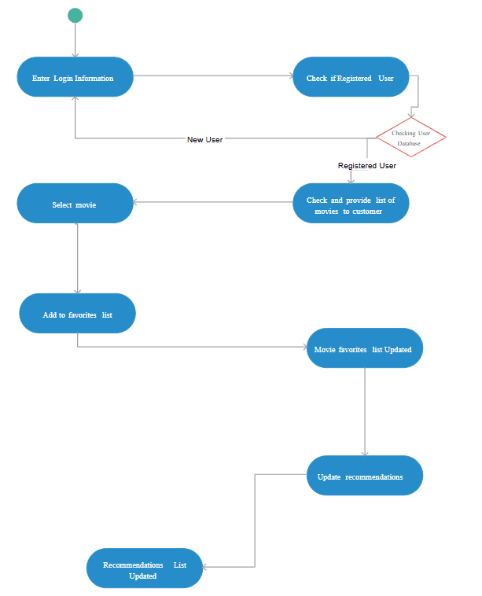
GANTT CHART

A Gantt Chart is a visual project management tool that shows the schedule of different tasks over a specific period of time. It represents activities on the vertical axis and time (days/weeks) on the horizontal axis, with bars indicating when each task starts and ends. It helps in planning, tracking progress, managing deadlines, and ensuring that all phases of the project—such as analysis, design, coding, and testing—are completed in a structured and timely manner.
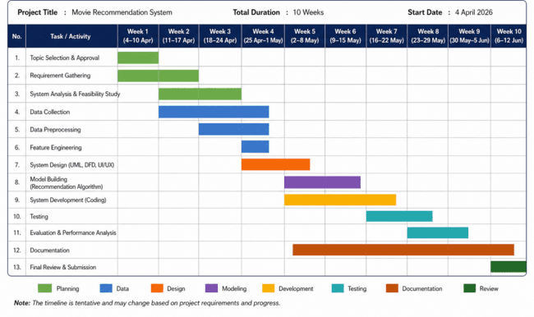

Software Requirement Specification (SRS)

Software Requirement Specification (SRS) is a detailed document that describes the functional and non-functional requirements of a software system. It acts as a blueprint for the development of the project and helps developers understand the objectives, features, and behavior of the system. The SRS document defines what the system should do and how it should perform under different conditions.
For the Movie Recommendation System, the Software Requirement Specification helps in identifying user needs, system functionalities, hardware and software requirements, and operational constraints. It also provides a clear understanding of the project structure and serves as a guide during the development and testing phases.
The SRS document is important because it reduces development confusion, improves communication between developers and users, and ensures that the final software system meets the required objectives.

1. PURPOSE OF THE SYSTEM
The main purpose of the Movie Recommendation System is to provide users with personalized movie suggestions according to their interests and preferences. The system helps users discover relevant movies from a large collection of available content in a simple and efficient manner.
The proposed system is designed to:
- Reduce the effort required for movie searching.
- Provide accurate movie recommendations.
- Improve user experience in movie selection.
- Demonstrate the practical implementation of recommendation systems using Python.

2. SCOPE OF THE SYSTEM
The Movie Recommendation System is intended to analyze movie data such as genres, ratings, and descriptions to recommend similar movies to users. The system focuses on implementing recommendation techniques using Python programming and machine learning libraries.
The application allows users to:
- Search for movies.
- View movie details.
- Receive personalized recommendations.
- Explore similar movies according to genres and ratings.
Initially, the project will use a limited movie dataset for educational purposes. However, the system can be enhanced in the future with advanced recommendation algorithms, user accounts, online APIs, and real-time movie updates.

3. OVERALL DESCRIPTION
The Movie Recommendation System is a software application that works by analyzing movie information and generating recommendations based on similarity between movies. The system compares genres, keywords, and other movie features to provide relevant suggestions.

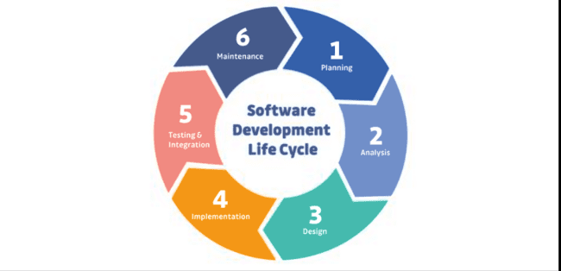

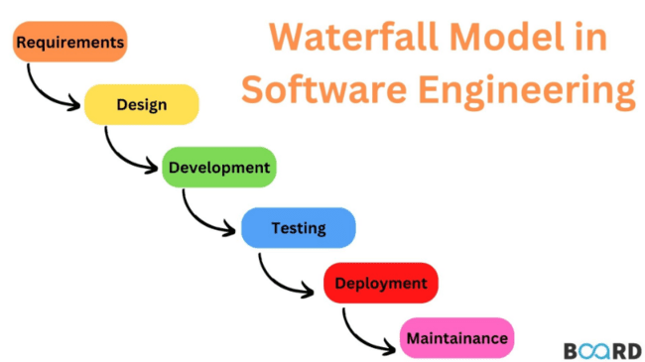

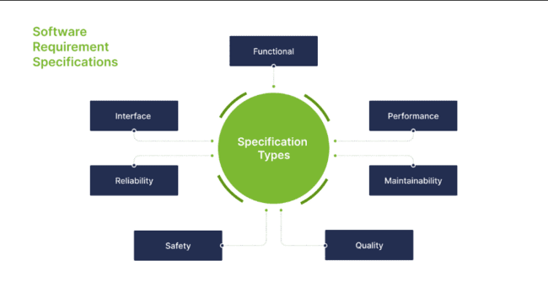

FIGURE – SOFTWARE DEVELOPMENT LIFE CYCLE

The application consists of the following major components:
- User Interface
- Movie Database
- Recommendation Engine
- Search Module
- Output Display Module
The recommendation engine is the core component of the system and is responsible for generating movie suggestions.

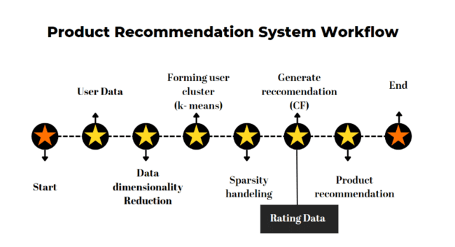

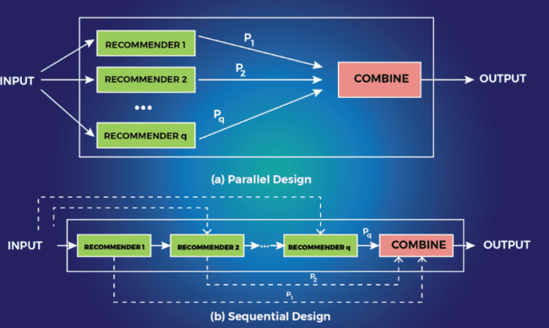

FIGURE – ARCHITECTURE OF MOVIE RECOMMENDATIONS SYSTEM

4. FUNCTIONAL REQUIREMENTS
Functional requirements describe the operations and services that the system must perform.

4.1 Movie Search Functionality
The system should allow users to search for movies using:
- Movie title
- Genre
- Keywords
- Ratings
Users can enter a movie name and the system will display related movie information and recommendations.

4.2 Movie Recommendation Functionality
The recommendation engine should generate recommendations based on:
- Similar genres
- Keywords
- Ratings
- Movie descriptions
The system should compare movie data and display similar movies to the user.

4.3 Display Movie Information
The system should display detailed movie information such as:
- Movie Title
- Genre
- Rating
- Description
- Release Year
This information helps users understand the recommended movies better.

4.4 Dataset Management
The system should maintain a structured dataset containing movie details. The dataset will be used by the recommendation engine for generating suggestions.

4.5 User Interaction
The system should provide a simple and interactive interface that allows users to easily navigate through the application and access recommendations efficiently.

NON-FUNCTIONAL REQUIREMENTS

Non-functional requirements define the quality attributes and performance characteristics of the system.

5.1 Performance Requirements
- The system should generate recommendations quickly.
- Search operations should take minimum time.
- The application should perform efficiently even with large datasets.

5.2 Reliability Requirements
- The recommendation system should provide accurate results.
- The application should function continuously without frequent failures.

5.3 Usability Requirements
- The user interface should be simple and user-friendly.
- Users should be able to operate the system without technical knowledge.

5.4 Security Requirements
- User inputs should be validated properly.
- Unauthorized access to the dataset should be restricted.
- The system should handle invalid inputs safely.

5.5 Maintainability Requirements
- The system should be easy to update and maintain.
- New movies and features should be added easily.

HARDWARE REQUIREMENTS

The following hardware components are required for developing and running the Movie Recommendation System:
Hardware Component | Requirement
Processor | Intel i3 or above
RAM | Minimum 4 GB
Storage | 500 GB Hard Disk
Monitor | Standard Display
Keyboard and Mouse | Required
The project can be developed on a normal laptop or desktop computer.

SOFTWARE REQUIREMENTS

The following software tools and technologies are required for the project:
Software | Purpose
Python | Programming Language
VS Code / PyCharm | Code Editor
Pandas | Data Handling
NumPy | Numerical Operations
Scikit-Learn | Recommendation Algorithm
MySQL | Database Management
Streamlit / Tkinter | User Interface
These tools are selected because they are efficient, easy to use, and suitable for recommendation system development.

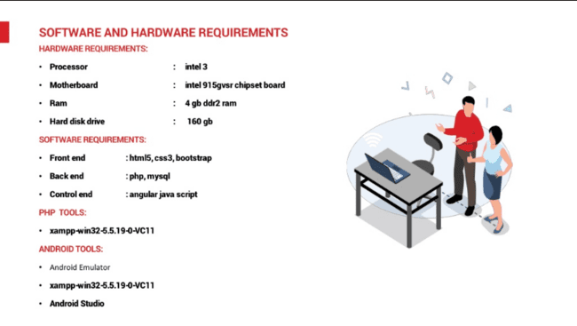

FIGURE – HARDWARE AND SOFTWARE REQUIREMENTS

8. SYSTEM CONSTRAINTS
System constraints are the limitations under which the project operates.
The constraints of the Movie Recommendation System are:
- The recommendation quality depends on the available dataset.
- Limited datasets may reduce recommendation accuracy.
- Internet connectivity may be required for future API integration.
- Advanced machine learning models may require higher computational resources.
Despite these limitations, the proposed system is effective for educational and demonstration purposes.

9. ASSUMPTIONS AND DEPENDENCIES
The project assumes that:
- The movie dataset is accurate and properly formatted.
- Required software libraries are installed correctly.
- Users provide valid movie input.
- The system environment supports Python execution.
The project also depends on external libraries such as Pandas and Scikit-Learn for recommendation processing.

10. USER INTERFACE REQUIREMENTS
The Movie Recommendation System should provide a clean and interactive user interface.
The interface should include:
- Search bar for entering movie names
- Recommendation display area
- Movie information section
- Navigation buttons
The interface should be easy to understand and attractive for users.

11. DATABASE REQUIREMENTS
The system database should store movie-related information such as:
- Movie ID
- Movie Title
- Genre
- Rating
- Description
The database should support fast searching and efficient recommendation generation.

12. ERROR HANDLING REQUIREMENTS
The system should handle errors effectively.
Examples include:
- Invalid movie names
- Missing dataset values
- Connection failures
- Incorrect user inputs
Proper error messages should be displayed to users to improve usability.

13. TESTING REQUIREMENTS
The system should undergo different testing techniques to ensure proper functionality.
The testing process includes:
- Unit Testing
- Integration Testing
- System Testing
- User Acceptance Testing
Testing helps identify and remove errors before final deployment.

14. FUTURE ENHANCEMENT REQUIREMENTS

The Movie Recommendation System can be enhanced in the future by adding:
- AI-based recommendation algorithms
- User login and profiles
- Watchlist feature
- Online movie APIs
- Real-time recommendations
- Movie poster integration
These enhancements will improve system functionality and user experience.

CONCLUSION OF SRS

The Software Requirement Specification provides a detailed description of the Movie Recommendation System and its functionalities. It defines the requirements, objectives, constraints, and technologies required for the successful development of the project.
The SRS document acts as a roadmap for the development process and ensures that the final software system meets user expectations and project goals effectively.

SOFTWARE ENGINEERING PARADIGM APPLIED

A software engineering paradigm is a systematic approach used for the development of software systems. It provides a structured method for planning, designing, developing, testing, and maintaining software applications. For the development of the Movie Recommendation System, the Waterfall Model of the Software Development Life Cycle (SDLC) has been applied as the software engineering paradigm.
The Waterfall Model is one of the simplest and most widely used software development models. In this model, software development is carried out in a sequential manner where one phase is completed before moving to the next phase. Each stage has specific objectives and outputs, which makes project management easier and more organized.
The following phases of the Waterfall Model were applied during the development of the Movie Recommendation System:

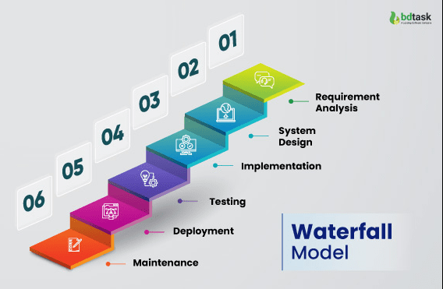

1. Requirement Analysis
In this phase, the requirements and objectives of the project were identified. The problems faced by users while selecting movies were studied, and the need for an intelligent recommendation system was analyzed. Functional and non-functional requirements of the system were also defined.

2. System Design
In the design phase, the overall structure of the system was prepared. This included designing the system architecture, database structure, user interface, and recommendation workflow. Diagrams such as DFD and system architecture diagrams were also planned during this stage.

3. Coding and Implementation
In this phase, the actual development of the project was performed using Python programming language. Libraries such as Pandas, NumPy, and Scikit-Learn were used to implement the recommendation algorithm and process movie data efficiently.

4. Testing
Testing was performed to identify and remove errors from the system. Different testing techniques such as unit testing, integration testing, and system testing were applied to ensure that the recommendation system worked correctly and efficiently.

5. Deployment and Maintenance
After successful testing, the system was prepared for final execution and demonstration. Future maintenance and enhancement possibilities were also considered, such as adding AI-based recommendations, user login systems, and online API integration.

The Waterfall Model was selected for this project because it is simple, easy to understand, and suitable for academic projects with clearly defined requirements. It provides proper documentation, systematic development, and better project management. Therefore, the Waterfall Model proved to be an effective software engineering paradigm for the successful development of the Movie Recommendation System.
DATA MODEL ( DFD )

A Data Flow Diagram (DFD) is a graphical representation that shows how data moves through a system, including where the data comes from, how it is processed, where it is stored, and where it goes.

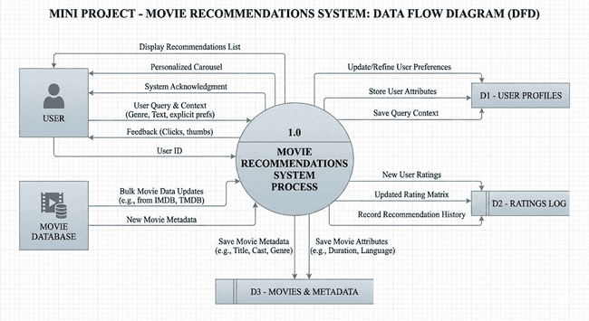

CONTROL FLOW DIAGRAM

A Control Flow Diagram is a graphical representation that illustrates the sequence of operations, decision points, and data flow within a system. It helps in understanding how control passes from one process to another during execution.

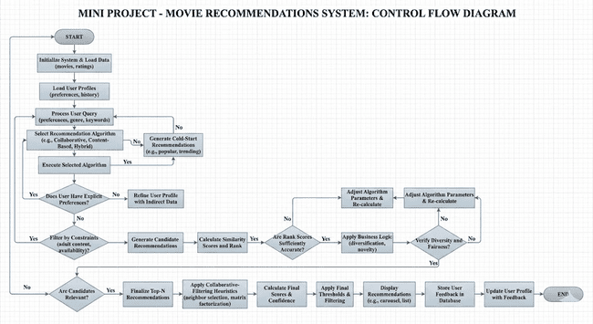

SEQUENCE DIAGRAM

A Sequence Diagram is a type of UML (Unified Modeling Language) diagram that shows the sequence of interactions between the user and different components of the system in a step-by-step manner.

Working Flow:
- User enters movie name.
- System receives user input.
- Recommendation engine processes the movie data.
- Database is searched for similar movies.
- Similarity calculation is performed.
- Recommended movies are generated.
- Results are displayed to the user.

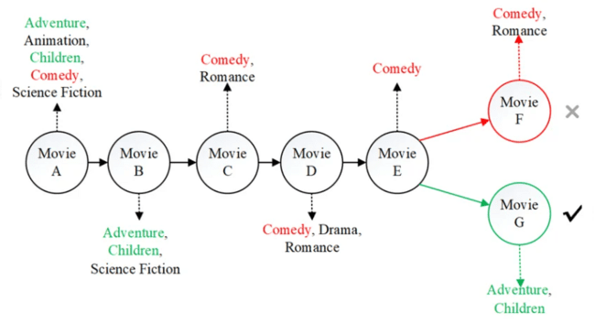

USE CASE DIAGRAM
A Use Case Diagram is a UML (Unified Modeling Language) diagram that represents the interaction between the user and the different functionalities of the system.

USE CASE DIAGRAM OF MOVIE RECOMMENDATIONS SYSTEM
The Use Case Diagram of the Movie Recommendation System shows how the user interacts with the application to perform different operations such as searching movies, viewing details, and receiving recommendations.

Main Use Cases Included:
Search Movie
- View Movie Details
- Get Recommendations
- Browse Movie List
- Display Similar Movies

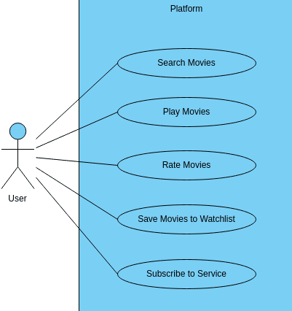
Main Actor:
- User

The user interacts with the system through the user interface and accesses different functionalities provided by the application.
SYSTEM DESIGN

MODULARISATION DETAILS
Modularisation is the process of dividing a software system into smaller and manageable units called modules. Each module performs a specific function and works together with other modules to complete the overall operation of the system. Modularisation improves system organization, simplifies development, reduces complexity, and makes maintenance easier.
In the Movie Recommendation System, the system is divided into different functional modules to ensure efficient processing and better management of the application. Each module is responsible for performing a particular task in the recommendation process.
The following modules are included in the proposed system:

1. User Interface Module
The User Interface Module provides interaction between the user and the system. It allows users to enter movie names, search movies, and view recommendations. This module is designed to be simple, user-friendly, and interactive so that users can operate the system easily.

2. Movie Database Module
The Movie Database Module stores movie-related information such as movie title, genre, ratings, keywords, release year, and descriptions. The database acts as the main source of data for generating recommendations.
This module is responsible for:
- Managing movie records
- Retrieving movie information
- Organizing datasets efficiently

3. Recommendation Engine Module
The Recommendation Engine is the core module of the system. It analyzes movie data and generates recommendations according to user input. This module uses content-based filtering techniques to identify similar movies based on genres, keywords, and ratings.
The recommendation engine performs the following tasks:
- Similarity calculation
- Recommendation generation
- Data processing and filtering

4. Search Module
The Search Module allows users to search for movies using movie names or genres. It processes user queries and retrieves matching movie records from the database.
This module helps users quickly locate movies and improves system usability.

5. Output Display Module
The Output Display Module presents the final recommendations and movie details to the user. It displays recommended movies in an organized format along with important information such as genre, rating, and description.
This module improves user experience by presenting results clearly and efficiently.

ADVANTAGES OF MODULARISATION
The modular design of the Movie Recommendation System provides several advantages:
- Simplifies system development
- Reduces system complexity
- Improves code management
- Makes testing easier
- Enhances maintainability
- Allows future modifications and enhancements
Each module can be developed, tested, and maintained independently, which increases the overall efficiency and reliability of the system.

Therefore, modularisation plays an important role in the design and development of the Movie Recommendation System by organizing the application into manageable components and ensuring systematic software development.

USER INTERFACE DESIGN
User Interface Design refers to the process of designing the visual layout and interaction structure of a software application. It focuses on creating an interface that is simple, attractive, user-friendly, and easy to operate. A well-designed user interface improves user experience and helps users interact with the system efficiently.
In the Movie Recommendation System, the user interface is designed to provide smooth interaction between the user and the application. The interface allows users to search for movies, view movie details, and receive personalized recommendations in a simple and organized manner.
The design of the interface focuses on simplicity, clarity, and ease of navigation so that users can operate the system without requiring technical knowledge.

MAIN COMPONENTS OF USER INTERFACE
The user interface of the Movie Recommendation System contains the following major components:

1. Home Page
The Home Page is the main screen of the application. It provides an introduction to the system and contains the movie search option. Users can enter the name of a movie and start the recommendation process from this page.
The home page includes:
- Project title
- Search bar
- Search button
- Navigation options

2. Search Interface
The Search Interface allows users to enter movie names or select genres according to their interests. The system processes the user input and searches the movie database for matching records.
This interface is designed to provide quick and easy movie searching functionality.

3. Recommendation Display Page
The Recommendation Display Page shows the list of recommended movies generated by the recommendation engine. The recommended movies are displayed in an organized format for better readability.
The displayed information may include:
- Movie Title
- Genre
- Rating
- Description
- Release Year

4. Movie Details Section
The Movie Details Section provides complete information about the selected movie. It helps users understand the recommended content better before making a selection.

5. Navigation and Interaction Controls
The system includes navigation buttons and interaction controls that help users move between different sections of the application smoothly. Proper navigation improves usability and user experience.

FEATURES OF THE USER INTERFACE
The user interface of the Movie Recommendation System has the following features:
- Simple and interactive design
- Easy navigation
- Fast response
- Clear display of recommendations
- User-friendly layout
- Organized presentation of movie data
The interface is developed in such a way that users can easily operate the system without confusion.

IMPORTANCE OF USER INTERFACE DESIGN

A good user interface plays an important role in the success of software applications. In the Movie Recommendation System, the interface improves communication between the user and the recommendation engine. It helps users access movie recommendations quickly and efficiently.
An effective user interface also increases user satisfaction, reduces complexity, and enhances the overall performance of the application.

Therefore, the User Interface Design of the Movie Recommendation System focuses on simplicity, usability, and efficient interaction to provide a better movie recommendation experience for users.

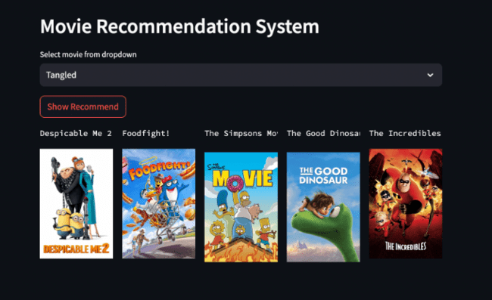

TESTING

TESTING TECHNIQUES AND STRATEGIES USED

Testing is an important phase of software development that is performed to identify errors, verify system functionality, and ensure that the software works according to user requirements. The main objective of testing is to improve software quality, reliability, and performance before final deployment.
In the Movie Recommendation System, various testing techniques and strategies were used to check the correctness of recommendation results, user interaction, database operations, and overall system performance. Proper testing helps in reducing errors and improving the efficiency of the application.

TESTING STRATEGY

The testing strategy used in the Movie Recommendation System follows a systematic approach in which different modules of the system are tested individually as well as collectively. The strategy focuses on verifying the recommendation engine, movie search functionality, dataset processing, and output display.
The testing process was performed in the following stages:
- Unit Testing
- Integration Testing
- System Testing
- User Acceptance Testing
These testing strategies helped ensure that the software system functioned properly under different conditions.

UNIT TESTING

Unit Testing is the process of testing individual modules or components of the system separately. Each module is checked independently to verify whether it performs the required operation correctly.
In the Movie Recommendation System, the following modules were tested individually:
- Movie Search Module
- Recommendation Engine
- Dataset Processing Module
- Output Display Module
For example, the recommendation engine was tested to verify whether it correctly generated similar movie suggestions according to user input.
Unit testing helped in identifying coding errors and logical mistakes during the development phase.

INTEGRATION TESTING

Integration Testing is performed after unit testing to verify whether different modules of the system work together correctly.
In this project, integration testing was used to check:
- Interaction between user interface and recommendation engine
- Data transfer between database and processing module
- Proper display of recommendation results
This testing ensured that all modules were properly connected and functioned as a complete system without communication errors.

SYSTEM TESTING

System Testing is the process of testing the complete software application as a whole. It verifies whether the entire system satisfies the specified requirements and performs correctly under real operating conditions.
The Movie Recommendation System was tested for:
- Accuracy of recommendations
- Search functionality
- User interface performance
- Response time
- Error handling
System testing confirmed that the software application operated efficiently and produced expected results.

4. USER ACCEPTANCE TESTING (UAT)

User Acceptance Testing is performed by users to verify whether the developed system fulfills their requirements and expectations.
In the Movie Recommendation System, users tested the application by entering movie names and checking the recommendations generated by the system. Feedback from users helped in improving usability and interface design.
UAT ensured that the system was user-friendly and suitable for practical use.

TEST CASES USED
The following sample test cases were used during testing:
Test Case ID | Input | Expected Output | Result
TC01 | Inception | Similar Movies Displayed | Pass
TC02 | Titanic | Romantic Movie Suggestions | Pass
TC03 | Invalid Movie Name | Error Message Displayed | Pass
These test cases helped verify the correctness and reliability of the system.

ADVANTAGES OF TESTING
The testing process provided several advantages:
- Improved software quality
- Reduced system errors
- Increased reliability
- Better recommendation accuracy
- Improved user satisfaction
- Enhanced system performance
Testing also ensured that the Movie Recommendation System was stable and ready for final implementation.

CONCLUSION

Testing techniques and strategies played a significant role in the successful development of the Movie Recommendation System. Different testing methods such as Unit Testing, Integration Testing, System Testing, and User Acceptance Testing were applied to verify system functionality and remove errors effectively.
The testing process improved software reliability, recommendation accuracy, and overall user experience. Therefore, proper testing ensured the successful implementation and efficient performance of the Movie Recommendation System.

SECURITY MEASURES

IMPLEMENTATION OF SECURITY FOR THE PROJECT DEVELOPED

Security is an important aspect of software development because it protects the system from unauthorized access, data misuse, and operational errors. A secure software application ensures the safety of data, improves system reliability, and provides a safe environment for users.
In the Movie Recommendation System, several security measures were implemented to ensure proper functioning of the application and protection of movie data and user interactions. Although the project is developed mainly for educational purposes, basic security techniques were applied to improve system safety and reliability.
The implementation of security measures helps in preventing invalid operations, reducing system vulnerabilities, and improving the overall performance of the application.

1.INPUT VALIDATION

Input validation is one of the most important security measures implemented in the system. Users may sometimes enter incorrect or invalid movie names, special characters, or empty inputs. Therefore, the system validates user input before processing it.
The following validations were applied:
- Checking for empty input fields
- Preventing invalid movie names
- Restricting unnecessary special characters
- Displaying proper error messages for incorrect input
Input validation helps in preventing system crashes and improves application stability.

2.ERROR HANDLING

Proper error handling techniques were implemented to ensure smooth system execution. During recommendation processing or dataset handling, unexpected errors may occur due to missing values or invalid operations.
The system handles such situations by:
- Displaying user-friendly error messages
- Preventing application termination
- Managing missing or incorrect dataset values
- Handling invalid search operations safely
Error handling improves software reliability and user experience.

3. DATABASE SECURITY
The movie dataset used in the system is maintained securely to prevent unauthorized modification or accidental loss of data.
The following database security measures were applied:
- Restricted direct access to dataset files
- Proper organization of movie records
- Backup of important data files
- Controlled dataset modification
These measures help maintain data consistency and reliability.

4. ACCESS CONTROL
Basic access control mechanisms were considered during project development. Only authorized users or developers can modify the system code and database files.
This prevents:
- Unauthorized modifications
- Accidental deletion of files
- Misuse of project resources
Access control improves system protection and software management.

5. SECURE CODING PRACTICES
Secure coding practices were followed during the implementation of the Movie Recommendation System to reduce software vulnerabilities and improve code quality.
The following practices were applied:
- Proper variable handling
- Organized coding structure
- Removal of unnecessary code
- Prevention of runtime errors
- Proper exception handling
These coding techniques improve software maintainability and security.

6. DATA INTEGRITY
Data integrity ensures that movie information remains accurate and unchanged during system processing.
The system maintains data integrity by:
- Using structured datasets
- Preventing duplicate records
- Verifying movie information before processing
- Maintaining proper data formatting
This helps generate accurate movie recommendations and improves system efficiency.

7. SYSTEM RELIABILITY AND STABILITY
Security implementation also focuses on improving the reliability and stability of the application. The system was tested under different conditions to ensure smooth performance and continuous operation.
Measures taken include:
- Regular testing of modules
- Removal of software bugs
- Performance monitoring
- Efficient handling of recommendation operations
These measures reduce system failures and improve software performance.

FUTURE SECURITY ENHANCEMENTS

The Movie Recommendation System can be enhanced further in the future by implementing advanced security techniques such as:
- User authentication and login system
- Password encryption
- Secure API integration
- Cloud database security
- Role-based access control
These enhancements will provide stronger protection and improve overall system security.

CONCLUSION

Security measures play an important role in the successful implementation of software systems. In the Movie Recommendation System, various security techniques such as input validation, error handling, database security, access control, and secure coding practices were implemented to ensure safe and reliable system operation.
These security measures improved software stability, prevented unauthorized operations, and enhanced user experience. Therefore, proper implementation of security techniques contributed significantly to the efficient and secure functioning of the Movie Recommendation System.

REPORTS
Reports are an important part of any software system because they help in presenting processed information in an organized and understandable manner. Reports provide useful details about system activities, outputs, and results generated by the application. In the Movie Recommendation System, reports help users and developers analyze movie recommendations, user searches, and system performance effectively.
The system is capable of generating different types of reports related to movie recommendations and user interactions. These reports improve system usability and help in understanding the functioning of the recommendation process.
The major reports generated by the system are as follows:

1. Movie Recommendation Report
This report contains the list of movies recommended by the system according to the movie selected by the user. It displays relevant movies along with important details such as genre, rating, and description.
The recommendation report helps users quickly identify movies that match their interests and preferences.

2. Movie Search Report
The Movie Search Report stores and displays information about movie searches performed by users. It helps in analyzing frequently searched movies and understanding user interests.
This report can also be useful for improving recommendation accuracy in future enhancements.

3. Movie Details Report
This report provides detailed information about individual movies available in the database. It may include:
- Movie Title
- Genre
- Rating
- Release Year
- Description
The report helps users understand movie information before selecting recommendations.

4. System Performance Report
The System Performance Report is used to monitor the efficiency and performance of the recommendation system. It helps developers analyze:
- Recommendation accuracy
- Processing speed
- Search efficiency
- Error handling performance
This report is useful for improving the quality and reliability of the system.

IMPORTANCE OF REPORTS

Reports improve system management and provide organized information to users and developers. They help in:
- Better data analysis
- Monitoring recommendation performance
- Understanding user behavior
- Improving system efficiency
- Maintaining proper documentation
Therefore, reports play an important role in the effective functioning and analysis of the Movie Recommendation System.

FUTURE SCOPE AND FUTURE ENHANCEMENT OF THE PROJECT
The Movie Recommendation System has significant future scope because recommendation technologies are widely used in modern digital entertainment platforms. The proposed system provides a strong foundation for implementing intelligent recommendation techniques and can be enhanced further by integrating advanced technologies and additional functionalities.
Currently, the system recommends movies based on movie similarity, genres, and ratings using content-based filtering techniques. In the future, the project can be improved by implementing advanced machine learning and artificial intelligence algorithms to provide more accurate and personalized recommendations according to user behavior and viewing history.
One of the major future enhancements of the project is the implementation of a User Login and Authentication System. This feature will allow users to create personal accounts, save favorite movies, maintain watchlists, and receive recommendations based on their individual preferences.
The system can also be integrated with online movie databases and APIs such as IMDb or TMDb to fetch real-time movie information, ratings, posters, trailers, and reviews. This enhancement will make the application more dynamic and interactive.
Another important future enhancement is the development of a web-based or mobile application version of the project. This will increase accessibility and allow users to use the recommendation system from smartphones and other devices.
The project can also be expanded by adding features such as:
- Movie Poster Display
- Voice Search Functionality
- Multi-language Support
- User Reviews and Ratings
- AI-based Recommendation Engine
- Streaming Platform Integration
Advanced recommendation techniques such as collaborative filtering and hybrid recommendation systems can also be implemented to improve recommendation accuracy and system intelligence.
In the future, the Movie Recommendation System can be used not only for educational purposes but also for practical applications in entertainment platforms, online streaming services, and media recommendation systems.
Therefore, the project has wide future scope and enhancement possibilities, making it a valuable and expandable software application in the field of intelligent recommendation systems.
APPENDICES

#CODING

# =========================================================
# MOVIE RECOMMENDATION SYSTEM
# =========================================================

# -------------------------
# IMPORTING LIBRARIES
# -------------------------

import pandas as pd
import numpy as np
import matplotlib.pyplot as plt
import seaborn as sns

# =========================================================
# CREATING MOVIE DATA
# =========================================================

movie_data = {

'Movie_Name': [
'Inception',
'Titanic',
'Avatar',
'Interstellar',
'The Dark Knight',
'Avengers Endgame',
'Doctor Strange',
'Dune',
'The Matrix',
'Gravity'
],

'Genre': [
'Sci-Fi',
'Romance',
'Sci-Fi',
'Sci-Fi',
'Action',
'Action',
'Sci-Fi',
'Sci-Fi',
'Sci-Fi',
'Sci-Fi'
],

'Rating': [
8.8,
7.9,
7.8,
8.6,
9.0,
8.4,
7.5,
8.2,
8.7,
7.7
],

'Year': [
2010,
1997,
2009,
2014,
2008,
2019,
2016,
2021,
1999,
2013
]
}

# =========================================================
# CREATING PANDAS DATAFRAME
# =========================================================

movies = pd.DataFrame(movie_data)

# =========================================================
# DISPLAYING COMPLETE DATA
# =========================================================

print("
================ MOVIE DATASET ================
")
print(movies)

# =========================================================
# DISPLAYING BASIC INFORMATION
# =========================================================

print("
=============== DATASET INFORMATION ===============
")
print(movies.info())

# =========================================================
# CHECKING NULL VALUES
# =========================================================

print("
=============== NULL VALUES ===============
")
print(movies.isnull().sum())

# =========================================================
# DISPLAYING TOP RATED MOVIES
# =========================================================

print("
=============== TOP RATED MOVIES ===============
")

sorted_movies = movies.sort_values(by='Rating', ascending=False)

print(sorted_movies)

# =========================================================
# SEARCH MOVIE FUNCTION
# =========================================================

def search_movie(movie_name):

found = movies[movies['Movie_Name'].str.lower() == movie_name.lower()]

if len(found) > 0:

print("
Movie Found Successfully!
")
print(found)

else:

print("
Movie Not Found!
")

# =========================================================
# RECOMMEND MOVIES ACCORDING TO GENRE
# =========================================================

def recommend_movie(movie_name):

movie_name = movie_name.lower()

selected_movie = movies[
movies['Movie_Name'].str.lower() == movie_name
]

if len(selected_movie) == 0:

print("
Movie Not Found In Database!
")
return

genre = selected_movie.iloc[0]['Genre']

print("
Selected Movie Genre:", genre)

recommendations = movies[
movies['Genre'] == genre
]

print("
=========== RECOMMENDED MOVIES ===========
")

for i in range(len(recommendations)):

print(
i + 1,
".",
recommendations.iloc[i]['Movie_Name'],
" Rating:",
recommendations.iloc[i]['Rating']
)

# =========================================================
# CALCULATING AVERAGE RATING
# =========================================================

average_rating = np.mean(movies['Rating'])

print("
Average Movie Rating:", average_rating)

# =========================================================
# HIGHEST RATED MOVIE
# =========================================================

highest = movies[movies['Rating'] == movies['Rating'].max()]

print("
=============== HIGHEST RATED MOVIE ===============
")
print(highest)

# =========================================================
# LOWEST RATED MOVIE
# =========================================================

lowest = movies[movies['Rating'] == movies['Rating'].min()]

print("
=============== LOWEST RATED MOVIE ===============
")
print(lowest)

# =========================================================
# COUNT MOVIES GENRE WISE
# =========================================================

print("
=============== GENRE COUNTS ===============
")

print(movies['Genre'].value_counts())

# =========================================================
# VISUALIZATION USING MATPLOTLIB
# =========================================================

plt.figure(figsize=(10, 5))

plt.bar(
movies['Movie_Name'],
movies['Rating']
)

plt.title('Movie Ratings')
plt.xlabel('Movies')
plt.ylabel('Ratings')
plt.xticks(rotation=45)

plt.show()

# =========================================================
# VISUALIZATION USING SEABORN
# =========================================================

plt.figure(figsize=(8, 5))

sns.countplot(x='Genre', data=movies)

plt.title('Movies According To Genre')

plt.show()

# =========================================================
# HISTOGRAM OF MOVIE RATINGS
# =========================================================

plt.figure(figsize=(8, 5))

plt.hist(movies['Rating'])

plt.title('Distribution Of Ratings')
plt.xlabel('Ratings')
plt.ylabel('Frequency')

plt.show()

# =========================================================
# PIE CHART OF GENRES
# =========================================================

genre_counts = movies['Genre'].value_counts()

plt.figure(figsize=(7, 7))

plt.pie(
genre_counts,
labels=genre_counts.index,
autopct='%1.1f%%'
)

plt.title('Genre Percentage')

plt.show()

# =========================================================
# USER INTERACTION MENU
# =========================================================

while True:

print("
")
print("=========== MOVIE RECOMMENDATION MENU ===========")
print("1. Display All Movies")
print("2. Search Movie")
print("3. Recommend Movies")
print("4. Show Top Rated Movies")
print("5. Exit")

choice = int(input("
Enter Your Choice: "))

# =====================================================
# OPTION 1
# =====================================================

if choice == 1:

print("
=============== ALL MOVIES ===============
")
print(movies)

# =====================================================
# OPTION 2
# =====================================================

elif choice == 2:

name = input("
Enter Movie Name To Search: ")

search_movie(name)

# =====================================================
# OPTION 3
# =====================================================

elif choice == 3:

name = input("
Enter Movie Name: ")

recommend_movie(name)

# =====================================================
# OPTION 4
# =====================================================

elif choice == 4:

print("
=============== TOP MOVIES ===============
")
print(sorted_movies.head())

# =====================================================
# OPTION 5
# =====================================================

elif choice == 5:

print("
Thank You For Using Movie Recommendation System")
break

# =====================================================
# INVALID CHOICE
# =====================================================

else:

print("
Invalid Choice! Please Try Again.")

# =========================================================
# END
# =========================================================

BIBLIOGRAPHY

The following books, websites, research materials, and online resources were referred to during the development of the Movie Recommendations System project report and coding implementation.

BOOKS REFERRED
- Python Crash Course
— Used for understanding Python programming concepts and project development.
- Data Science from Scratch
— Referred for basic data analysis and recommendation concepts.
- Introduction to Machine Learning with Python
— Used for recommendation system understanding and data processing techniques.
- Fundamentals of Software Engineering
— Referred for SDLC, SRS, testing, and software engineering concepts.
- Programming in Python 3
— Used for Python syntax, functions, loops, and file handling concepts.

WEBSITES REFERRED
- Python Official Documentation
— Used for Python programming reference and library documentation.
- Pandas Documentation
— Referred for DataFrame handling and data analysis operations.
- NumPy Documentation
— Used for numerical operations and array concepts.
- Matplotlib Documentation
— Referred for graph plotting and data visualization.
- Seaborn Documentation
— Used for statistical and attractive graph visualization.
- Scikit-Learn Documentation
— Referred for recommendation concepts and similarity calculations.
- Kaggle
— Used for movie datasets and project reference materials.
- W3Schools Python Tutorial
— Used for basic Python syntax and examples.
- GeeksforGeeks
— Referred for programming examples and project guidance.

RESEARCH AND ONLINE REFERENCES
- Articles and tutorials related to recommendation systems and movie analytics.
- Online video tutorials for Python project development and data visualization.
- Educational materials related to Software Engineering and Machine Learning concepts.

